Forwarding from Gmail Student Account

1. Log in to your student email account by clicking the “student Gmail” link on the right side of the Olathe student website (http://students.olatheschools.com/).

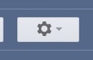
2. Find the settings button near the top right corner of the Gmail home screen and click “settings” in the drop down menu.

3. Go to the “Forwarding and POP/MAP” tab near the top center of the screen.

4. Click “Add a forwarding address” near the top center of the screen.

5. Type in the email address that you check most frequently and consistently! Then click “Next” and then “Proceed.”
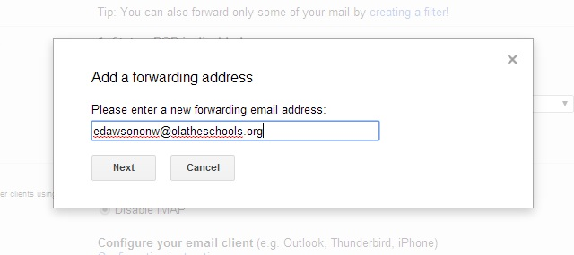

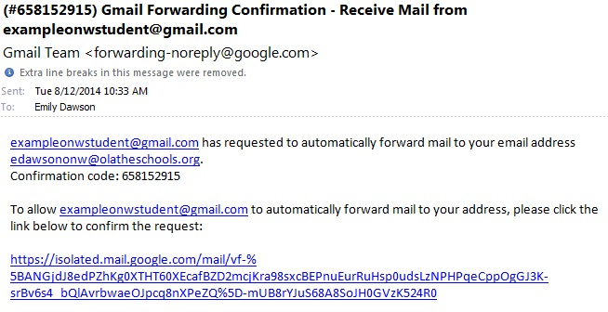
6. Now log in to your frequently-checked email and click the confirmation link that should have been sent from Gmail. You will be taken to a screen that says “Confirmation success!”

7. Go back to the Gmail “Forwarding and POP/MAP” menu from the settings page in your student email account. If you never left this site, make sure you refresh the page.

8. Click on the option to “Forward a copy of incoming mail to…” and choose the options that you’d prefer from the drop down menus.
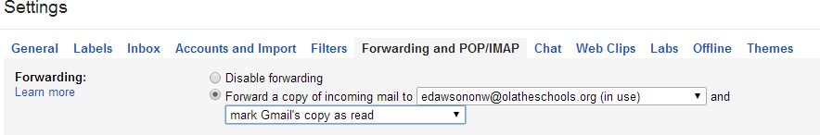

9. Make sure you click “Save Changes” at the bottom of the screen.

